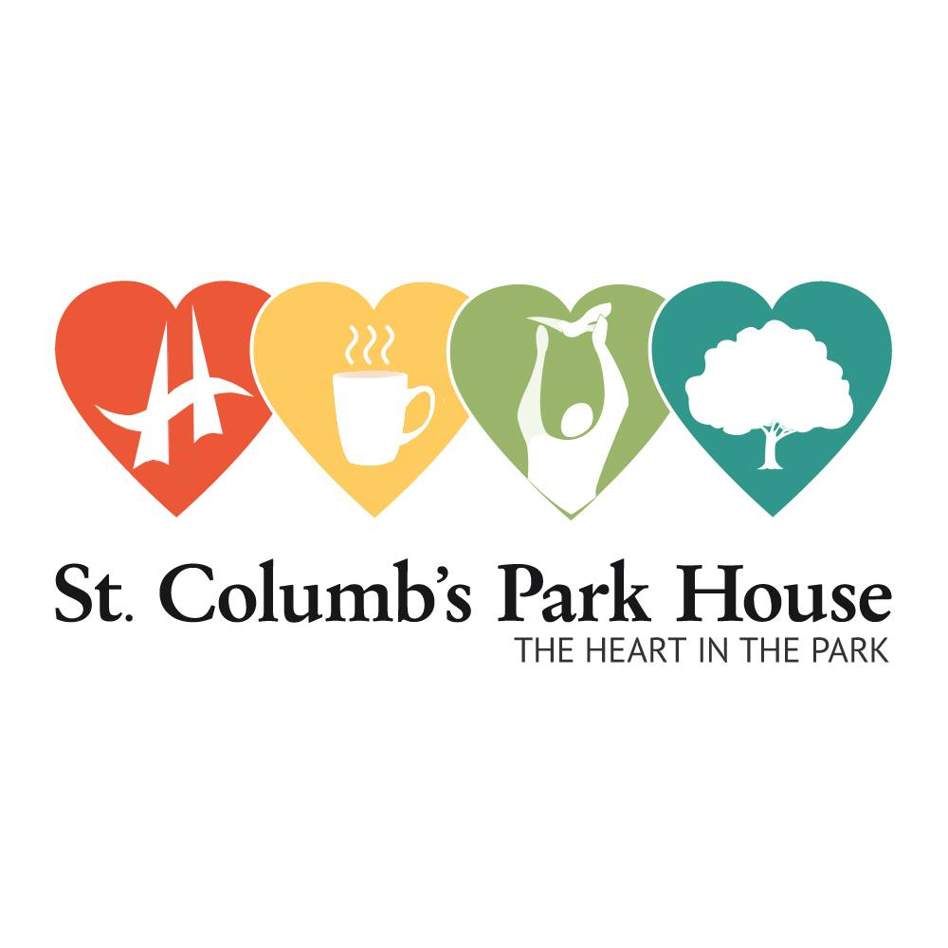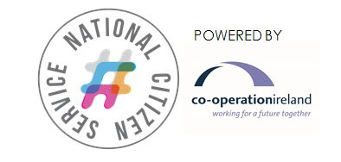

March 2018

Dear Parent/Guardian,

**We’re delighted that your teenager has expressed an interest in taking part in the Northern Ireland National Citizen Service (NI NCS) this summer and we write with further information and an application pack.**

**With a choice between a Summer or Autumn programme in 2018, NI NCS is a once in a lifetime opportunity for 15-17 year olds in Northern Ireland** to build skills for employment such as resilience, confidence and leadership, build trust between people of different backgrounds, and create stronger communities where giving back is a way of life.

NI NCS is open to all, regardless of background, experience or whether their strengths lie in sport, creativity or academics, with additional support provided to young people with learning or physical needs.

St. Columb’s Park House, in partnership with Co-operation Ireland, have delivered NCS in the North West and on the North Coast since 2012. In Northern Ireland, the programme has over 2000 graduates to date. Nationally, more than two million hours have been volunteered by almost 300,000 NCS participants in communities across England and Northern Ireland.

It’s important to us that as many young people as possible get to take part so the programme takes place outside the school timetable, during the holidays. With funding from the Department for Communities and the Honourable Irish Society, participation fees are capped at £50 for the summer programme with financial support available on a case-by-case basis.

St. Columb’s Park House have 2 teams in Derry/Londonderry, and 1 team in Coleraine, with 15 participants per team.

NCS consists of 3 phases over the summer holidays for around 6 weeks:

1. **1-5 July: Adventure**

Participants spend 4 nights away from home atThe Share Centre in Fermanagh, getting to know the team and being challenged by instructor-led group activities such as kayaking, sailing, and mountain biking.

1. **21-25 July: Discovery**

During a second 4 night residential closer to home, teams will take part in workshops to develop skills for life and work, as well as issue based awareness sessions to help prepare for social action. (The Coleraine Team will go to St. Columb’s Park House, Derry/ Londonderry; Both Derry/Londonderry teams will go to Tullarvan Mill, Buncrana)

1. **26 July -12 August: Social Action**

Back at home, teams identify issues that they care about in their community, then devise and deliver a social action project to make a difference. Projects range from fundraisers for chosen charities, awareness campaigns for local and youth issues, or regenerating public spaces. This stage is up to 60 hours – the first 30 hours will be spent planning at set times, and the additional hours used to carry out the team’s planned project.

Once the programme is completed, it’s time to celebrate with graduation (**Monday 20th August at Belfast City Hall**) - receiving a certificate signed by the Prime Minister and a 100-hour Millennium Volunteer award, supplied by Volunteer Now. We then work to provide opportunities for young people to continue with their journey and further volunteering as NCS graduates.

When we receive your application form, we will get in touch to let you know if your son/daughter has a place. Going forward then, a dedicated team leader will be the point of contact to keep you up to date on exact dates, locations and arrangements. **Please note that the team leader will not be in post until April, so please don’t panic if you don’t hear from them straight away**. They will be in touch though in plenty of time to help you and your teenager prepare for going away on programme.

Payment of £50 will be required in advance of the first residential, or you can apply for a bursary to cover this fee (bursary application is included in this pack). You can send us a cheque payable to Co-operation Ireland, or you can pay Co-operation Ireland directly by cheque or by card over the phone (028 90 321462).

If you have any questions please do not hesitate to contact me: **Darragh Graham, ncs@stcolumbsparkhouse.org, 07478 223507** or **028 71343080**.

We very much look forward to hearing from you soon.

Yours sincerely,

Darragh Graham

NCS Coordinator, Coleraine & Derry/Londonderry

Please send your completed forms to:

**Darragh Graham,**

**St. Columb’s Park House,**

**4 Limavady Road,**

**Derry/Londonderry,**

**BT47 6JY**

Or send a scan to **NCS@stcolumbsparkhouse.org**



**Northern Ireland** **National Citizen Service (NI NCS)**

Summer 2018

**Sign Up Information & Consent Form**

To be completed by, or on behalf of, the participant and signed by a duly authorised parent, guardian or carer (“The Signatory”). PLEASE PRINT CLEARLY.

Please return the consent section (pages 5-8) to

**Darragh Graham,**

**St. Columb’s Park House,**

**4 Limavady Rd,**

**Derry/Londonderry,**

**BT47 6JY**.

Or send a scan/picture of your application to [**NCS@StColumbsParkHouse.org**](mailto:NCS@StColumbsParkHouse.org)

* **Please note that completion of this form does not guarantee a place.**
* **Participants must attend ALL phases of the programme** (Phase 1: 1-5 July, Phase 2: 21-25 July, Phase 3: 26 July – 12 August)
* **Places will be allocated on a first come first serve basis in line with set criteria (please see terms and conditions, 2.1, for more information on criteria).**
* **Participants must have turned 15 by 1st July 2018 and be under 18 on the 25th July 2018.**
* **Participants cannot do NI NCS if they have done so before.**
* **Special cases can be made for those over 18 in the case of disability or missing a year at school.**

**Payment**

Places to teams will be assigned on receipt of this form and according to criteria. However, payment of £50 (or decision on award of bursary) will be required in advance of the residential to secure a place. If you wish to send payment with this form, please send a cheque made payable to **Co-operation Ireland**. Co-operation Ireland can also accept payment by card over the phone (028 90 321462).

The application form for bursary (financial assistance) is included in this pack and should be returned along with the consent form at the time of application.

**National Citizen Service, Summer 2018 – Teams, Dates & Locations**

**All three phases of the programme must be completed in order to graduate from NI NCS, with at least 90% attendance**

There are three distinct phases:

**Phase 1: Adventure** & Team Building (1-5 July)

**Phase 2: Discovery** & Skills (21-25 July)

**Phase 3: Social Action** (26 July -12 August)

Phase 3 is non-residential and will take place in venues local to the team members.

Graduation & Celebration Event – 23 August 2018. (Attendance at graduation is not compulsory to graduate).

There will be 1 team in Coleraine and 2 teams in Derry/Londonderry. There are 15 places per team.

|  |  |  |  |
| --- | --- | --- | --- |
| **Locality** | **Adventure Residential** | **Discovery Residential** | **Social Action** |
| **Coleraine & North Coast** | **1-5 July, Share Centre** | **21-25 July,**  **St. Columb’s Park House** | **26 July -12 August,**  **Local to Coleraine** |
| **Derry/ Londonderry** | **1-5 July, Share Centre** | **21-25 July,**  **Tullarvan Mill, Buncrana** | **26 July -12 August,**  **Local to Derry/Londonderry)** |

Each team of young people will be staffed throughout the programme by a team leader, a mentor, and a team volunteer. Contact details for these staff will be available in May.

**NI NCS Regional Delivery Provider Contact Details (Co-operation Ireland)**

Co-operation Ireland, Unit 5, Weaver’s Court, Linfield Road, Belfast, BT12 5GH

Project Coordinators

**Corinna Crooks** (delivery)

ccrooks@cooperationireland.org

02890 321462 or 07900 922954

**Sharon Woods** (financial & logistics)

swoods@cooperationireland.org

02890 321462 or 07712 578745

**Northern Ireland National Citizen Service (NI NCS) - Terms and Conditions**

**1. Information about us**

1. References in these Terms and Conditions to “we” or “us” are references to the delivery provider, a consortium led by Co-operation Ireland with local delivery partners: Belfast YMCA; YouthAction Northern Ireland; Youthworks NI; Start360; St Columb’s Park House; Share Village; Greenhill YMCA; Volunteer Now; NCS Trust
2. NCS in Northern Ireland is supported by the Northern Ireland Executive through the Department for Communities with additional sponsorship from the Honorable Irish Society to support young people in County Londonderry
3. You can contact us if you have queries in relation to your booking or for any other reason on 02890321462 or email [ccrooks@cooperationireland.org](mailto:ccrooks@cooperationireland.org)

**2 Your Booking**

1. By filling out and signing the Booking Form you are submitting a request to book a place on the NI National Citizen Service programme. All requests are subject to acceptance on confirmation of the booking, and receipt of payment or acceptance of a bursary application. Places will be allocated on a first come, first serve basis, applying the following criteria in order to uphold the NCS principle of social mixing: no more than 40% of any team from the same school or youth group; no more than 65% of one gender.

**3 If you have to cancel your Booking**

1. To cancel your Booking please contact us via email, phone or post explaining that you would like to cancel. If you have made payment prior to cancellation, in some circumstances refunds may be issued but this will be at our discretion.

**4 Our Staff**

1. Co-operation Ireland are committed to safeguarding and promoting the welfare of young people and expects all staff, volunteers, parents and partner agencies and commissioned services to share this commitment.
2. We confirm that we require our delivery staff to be subject to criminal disclosure checks.

**5 Liability**

1. The booking form contains certain information and disclaimers which, by signing the form, you accept that in the absence of any negligence on our part, participation in the NI National Citizen Service programme is at your own risk.
2. We have public liability insurance cover of at least £5 million.
3. We do not accept liability for loss or theft of personal belongings that occurs while on the programme. If the participant brings valuables with them this will be at your risk.

**6 Complaints**

1. We are committed to ensuring your young person has a great experience but if you or your young person is not entirely happy with their experience please contact their team leader in the first instance or the Delivery Partner in your area. If your complaint has not been resolved to your satisfaction please contact Co-operation Ireland using the contact details in Clause 1 with full details of the complaint and we will attempt to resolve it as quickly as possible.

**7 Medical/Dietary/Other Requirements**

1. If any young person included on your Booking (a) has specific dietary requirements; (b) is taking medication; (c) has allergies; and/or (d) has any special needs that will affect his or her participation in the programme it is your responsibility to inform us of this and provide all necessary details about this at the time of Booking.
2. Please note that our staff are not permitted to take responsibility for or to administer medicines and therefore you are responsible for ensuring any medication is available and taken correctly.
3. We will maintain a register of the participants attending the programme.

**8 Travel & Collection**

8.1 During the community phases of the programme the participant will be responsible for getting to and from agreed venues and will be allowed to leave without collection

* 1. For the residential venues or where transport facilities are provided as part of the project, the participant will be responsible for getting to and from the designated meeting location. Participants will only be allowed to leave from the meeting location and will be permitted to leave from that location without collection.
  2. By signing this form, you give us permission to allow the participant to leave designated locations (other than the residential or supervised trips) without collection, and to undertake some travel unsupervised.

**9 Discipline**

9.1 Participants on the programme will be treated with respect and must treat others including staff and other participants with respect. We reserve the right to refuse to allow your child to continue attending the programme if our staff deems their behaviour to be unacceptable. Codes of behaviour will be clearly outlined by each team leader at the beginning of the programme.

**10 Data Protection**

10.1 When you make a booking we will collect and process the personal information you provide in order to provide the services you have requested and for other specific purposes subject to your consent.

**11 Privacy Policy**

11.1 By ticking section 4 of the acceptance statement of this sign up form, you agree to your personal data being stored, shared and used by Co-operation Ireland and the following organisations: NCS delivery partners, strategic partners of NCS or other organisations (including any organisation running all or part of NCS in the future), the funder (NI Executive through the Department for Communities) and NCS Trust.

Your data will be used for the purposes of:

* Contacting you about the participant taking part in NCS
* Contacting you about taking part in press and communications activity related to NCS.
* Helping us develop, deliver and improve our service, content and advertising.
* Internal purposes such as auditing, evaluation, data analysis, preventing or detecting fraud or error, and research to improve our service and customer communications.

**12 Images**

12.1 During the course of NI NCS, activities may be recorded through photographas and video film both for the participants to collate their experiences but also for evaluation and promotional purposes by the local delivery provider, Co-operation Ireland, the Northern Ireland Executive through the Department for Communities, NCS Trust and partner agencies.

12.2 By ticking section 2 of the acceptance statement on this sign up form, you agree that the images may be used in media or publicity materials and celebration publications produced by those agencies. These images may be safely stores or archived digitally or manually and may be publicised in a variety of media forms including managed social network sites.

12.3 If you do not wish for the participant to be included in photographs and video materials for promotional purposes, you are required to clearly indicate this on the consent form.

**13 General**

13.1 The sign up form, these Terms and the Disclaimer set out the whole of the Agreement between you and us in relation to the subject matter of this Agreement and supersede any prior agreement, understanding or arrangement between us about such subject matter whether oral or in writing.



**NI NCS BURSARY APPLICATION SUMMER 2018**

Participation in NI NCS summer 2018 costs £50. If you feel that you are unable to pay this fee and if 1 or more of the below apply to you, you can apply for a bursary to cover it. Please return this form along with your application form. Statements refer to the young person who is applying for NCS.

Name of applicant:__________________________

Team applied for:__________________________

I am receiving free school meals

I am receiving the 16-19 Bursary or Education Maintenance Allowance at the highest rate (£30 per week in Northern Ireland)

Someone in my family (with whom I live) is receiving Income Support or income-based Jobseeker's Allowance or Employment and Support Allowance, and the benefit includes an element to help meet my needs.

I am newly homeless

I live in emergency housing

I am newly arrived in the country and have leave to stay

I am a carer

I am living independently

Any other circumstances not listed above?

Signatory name:___________________Status (e.g.parent/guardian,carer):________________________

Signature:______________________________________Date:__________________________________

Your application will be considered by your local NCS delivery partner in conjunction with Co-operation Ireland (NCS lead provider in Northern Ireland) and they will let you know their decision as quickly as possible. Please note that you do not need to provide evidence of the above at this point but you may be asked to do so in order to support your application.

**NI NCS Summer 2018 Consent Form**

**For Office Use**

**Date received:**

**Payment received:**

**Bursary applied for:**

**Local delivery provider:**

***Participant’s Details***

First Name:…………………………………………Last Name:…………………………………………………………….

First Line of Address:……………………………………………………………………………………………………………

Town/City:…………………………………………………………County:…………………………………………………

Team applied for (from the list provided on page 2) in order of preference:

1.………………………………………………………………………………………………………………………………….

2…………………………………………………………………………………………………………………………………..

Postcode:………………………………………………………………………………………………………………………

Date of Birth:…………………………………………Age on 27th June 2018……………………………………….

If the participant is aged 18 before 28/07/2018, please state case for inclusion (see notes above)

……………………………………………………………………………………………………………………………………

Mobile Number:………………………………………………………………………………………………………………

Email Address:…………………………………………………………………………………………………………………

Gender (please circle): Male/Female

Facebook/Twitter……………………………………………………………………………………………………………..

School/College………………………………………………………………………………………………………………

***Parent/Guardian Details*** (in case of emergency, we will use these details in the order detailed below – please provide at least 2 contacts and numbers where you can be easily contacted at all times)

**Contact 1**

Name:………………………………………………………………………………………………………………………….

Relationship to participant (parent/family friend etc.):……………………………………………………………

Contact details: (Mobile)………………………………………………………………………………………………..

(Home)………………………………………………(Email)………………………………………………………………

**Contact 2**

Name:………………………………………………………………………………………………………………………….

Relationship to participant:……………………………………………………………………………………………….

Contact details: (Mobile)…………………………………………………………………………………………………

(Home)………………………………………………(Email)………………………………………………………………

***What is the participant’s clothing size?***

S☐ M☐ L☐ XL☐

***How did the participant hear about NCS?***

School/college☐ Word of mouth☐ Advert☐

Facebook/Twitter/social media☐ Media article/programme☐

Youth group/organisation☐

The following information is to monitor if our NCS teams are representative of young people in Northern Ireland.

If you do not wish to answer these questions, it will not affect your application.

***What best describes the participant’s community background? (Please tick one)***

Protestant community background☐ Catholic community background☐

Mixed community background☐ Different community background from those above☐

Prefer not to say☐

***What best describes the participant’s ethnic background? (Please tick one)***

White☐ Traveller of Irish heritage ☐ Any other White background ☐

Traveller of Roma heritage ☐ Indian☐ Pakistani☐

Bangladeshi☐ Chinese☐ Any other Asian background☐

White and Asian☐ Black Caribbean☐ Black African☐

White and Black Caribbean☐ White and Black African☐ Any other Black background☐

Any other ethnic group☐ Any other Mixed background☐

None of these☐ Prefer not to say☐

**Is the participant eligible for free school meals?**

Yes☐ No☐ N/A☐

***Consent for water related activities***

During NI NCS the participant may get to take part in water related activities which may include but are not limited to swimming, kayaking, canoeing and rafting. While this list is not exhaustive please indicate below if you are happy for the participant to take part in such activities.

**Please tick here to give consent for the participant to participate in water related activities☐**

***Disclaimer and Medical Statement***

***It is important for the welfare and safety of the participants that you declare all medical conditions and information. In most cases it will not prevent the individual from participating but will allow us to provide suitable support for their needs.***

*Please tick the relevant box and provide further information if required*

Does the participant have a disability, either learning or physical? yes☐ no☐

Does the participant have any injuries, weakness, medical conditions, recurrent illnesses or allergies which may affect, or be affected by, exercise or physical contact? yes☐ no☐

Is the participant taking any medication or undergoing treatment that needs to be continued during the programme? yes☐ no☐

Is the participant known to be allergic or sensitive to anything (e.g. penicillin, aspirin or food types.)? yes☐ no☐

Does the participant have any specific dietary requirements (e.g. vegetarian/vegan etc.)? yes☐ no☐

Does the participant have any other particular additional needs that the delivery staff should be aware of? yes☐ no☐

If you have answered yes to any of the above questions, please give further details and any action/recommendations/medication required and/or any activity in which the participant cannot be involved. Continue on a separate sheet if necessary.

PLEASE NOTE:

* Staff are not permitted to take responsibility for or to administer medicines. You are therefore responsible for ensuring that any medicine is available and taken correctly.
* You understand that whilst involved in programme activities, the participant will be under care of the delivery staff and other suitably approved adults. Whilst we take all reasonable care of participants you acknowledge that in the absence of our negligence, participation in the programme is at your sole risk and that we shall not be liable for damage or injury arising from activities.
* In the unlikely event of an accident occurring, you provide your permission for us to seek emergency medical treatment, including use of anaesthetic if deemed necessary.

**Please tick here to confirm you accept our disclaimer and medical statement ☐**

***Acceptance***

**1.** I confirm that I have read and understood the terms & conditions, that all relevant information about the participant is correct and that I accept on behalf of myself and the participant all such conditions.

**☐ Please tick box**

**2.** I give consent for the participant’s image to be used for promotional and evaluation material (Terms & Conditions Section 12)

**☐ Please tick box**

**3.** I confirm that I have disclosed all necessary information regarding the participant’s medical and/or additional needs while on programme.

**☐ Please tick box**

**4.** I have read and accept the privacy policy (Terms & Conditions Section 11)

**☐ Please tick box**

**5.** I agree that the participant and parent/guardian contact details may be shared with NI NCS delivery partners for the purposes of facilitating participation in the programme, and for subsequently sharing information about further opportunities available to the participant as an NCS graduate.

**☐ Please tick box**

**6.** I understand and accept the need for acceptable and responsible behaviour on the participant’s part and have read and understood Section 9 of the terms & conditions regarding discipline.

**☐ Please tick box**

**7.** I confirm I have full authority to sign on behalf of the participant.

**☐ Please tick box**

Name of signatory (block letters)……………………………………………………………………………………….

Status (e.g. parent, guardian, carer)…………………………………………………………………………………

Signature…………………………………………………………………………………………………………………….

Date………………………………………………………………………………………………………………………….

**Please retain pages 1-3 for your records and return pages 5-8 to:**

**Darragh Graham, St. Columb’s Park House, 4 Limavady Rd, Derry/Londonderry, BT47 6JY**

**Or send a scan/picture of your application to NCS@StColumbsParkHouse.org**